Planner Instructions:

1. Download the Zerto Virtual Manager (ZVM) installer, version 7.0 update 1 or above, from [myzerto.com](http://www.myzerto.com/)
2. Install the ZVM at the customer site
   * Express installation, no specific setup is required.
   * VC admin credentials need to be provided.

• Online services should be left enabled (default). This secure, one-way data transmission is required for Zerto Analytics and the Planner tool.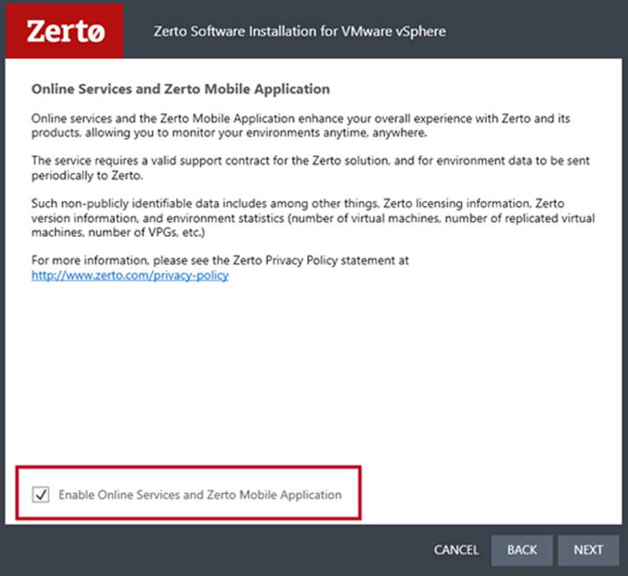

1. Setup the ZVM
   * Log in to ZVM and pair the site to your Cloud License, either via the ZCC (DRaaS) or the ZVM (ICDR).
   * In the ZVM’s settings, check again to ensure that the check box to opt-in to Zerto analytics is enabled.
   * Allow for at least 12 hours for data to fully populate the Planner tool.
2. Log in to Zerto Analytics and navigate to the "Planning" tab. Once there, left-click the button labelled “VM Selection”, seen below:

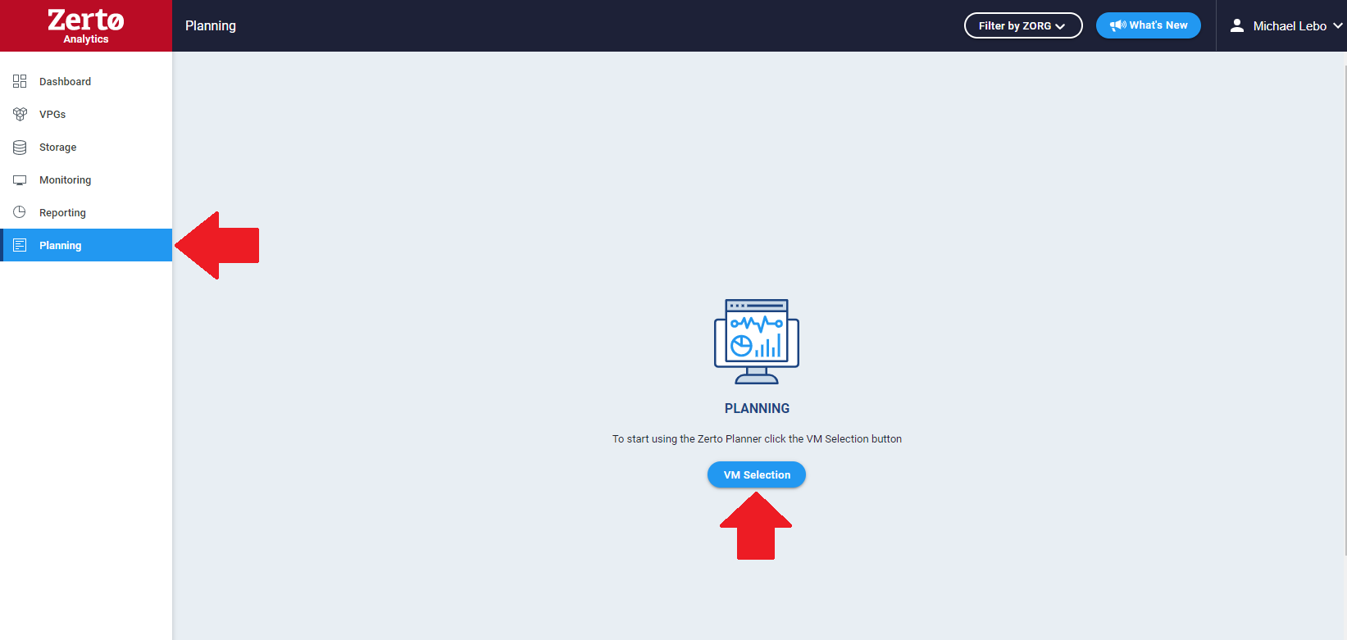

1. A new VM selection screen will pop-up within the Analytics. Once there, you will:
   * Select the desired Source Site
   * Select the desired target platform (Azure, AWS, On-prem)
   * Select the VMs that you wish to monitor from the left-hand panel. Use the arrows located in the center of the window to move the VMs to the right-hand panel for monitoring. Only these selected VMs will show in the planning report. Once completed, left-click the save button on the bottom-right corner:

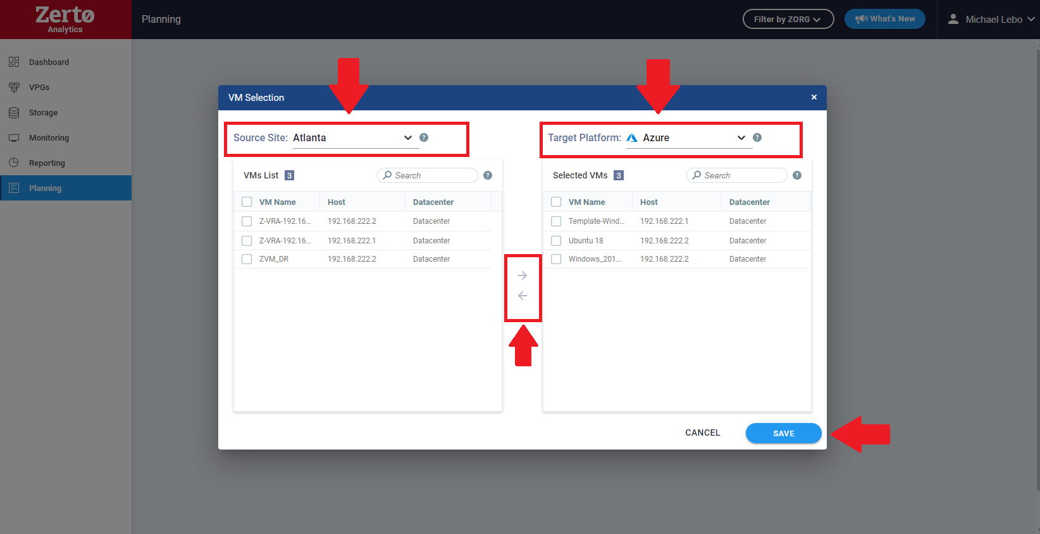

1. Once saved, the Planner will direct you to the generated report. Allow the Planner to monitor the VMs for an extended period by simply leaving the ZVM online for the desired timeframe (hours, days, or weeks). This will give a more accurate aggregate of the data for the Planner’s recommendations.

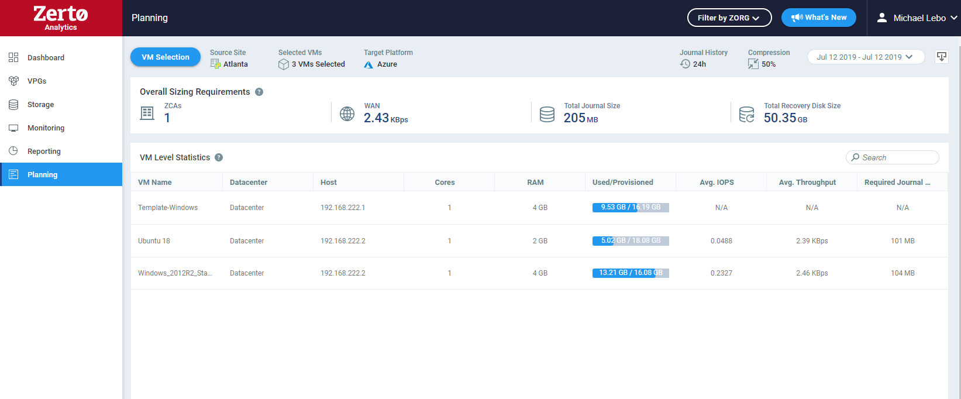

**Note:** On the top right-hand corner, there is a calendar timeline and an export option. The calendar allows you to select single or multiple days that the VMs have been monitored for, to show the aggregate data for that timeframe. If needed, the export button allows you to export the data into a report for the customer’s own viewing.

Considerations:

* ZVM queries the hypervisor to track IO behavior of all the source VMs
* The collected data is securely transmitted to your Zerto Analytics page
* Data is analyzed and is delivered in Zerto Analytics “Planning” tab
  + Based on the measured IO patterns of the source VMs.
  + Assumes 50% compression ratio and 24 hours of journal history. This will be customizable in later versions of the tool.

**Note:** The external zPlanner tool option is still available, but it will require its requested use and training from your Zerto Cloud Architect. This option can be leverage if the end-user doesn’t want to initially implement the ZVM. It will still deploy a VM within their environment via an OVF template, and its sizing requirements will be the same resources as a ZVM’s requirements would be. Because of this, it is strongly encouraged that the customer deploys the ZVM and doesn’t use this option. If circumstances require this option or you would like to know more, please contact your Zerto Account team for more information.